Manuscript for MEC 2019 Conference
John N. Smith
John.Smith@ulapland.fi
http://www.ulapland.fi/JohnSmith
University of Lapland
Centre for Media Pedagogy (CMP)
P.O. Box 122, FIN-96101 Rovaniemi, Finland
Tel: + 358 16 341 341, Fax: + 358 16 341 2401
This is a less than 250 words abstract of a fictional article demonstrating the typical elements of a NBE 2007 article. Abstract may be written in structured or unstructured form. In their most basic form, structured abstracts is based on following headings where possible: Aims and objectives; Background, stating what is already known about the topic; Design; Methods; Results; Conclusions, stating what this study adds to the topic. The abstract should accurately reflect the content of the paper. The abstract should not include references or abbreviations. The abstract should be followed by two to six keywords, which accurately identify the paper’s subject, purpose and focus. Abstract should emphasize new and important aspects of the study or observations. Authors must use this document as a basis of their articles. Feel free to copy and modify the given examples to suit your particular needs. This line simply extends the length of the abstract. This line simply extends the length of the abstract. This line simply extends the length of the abstract. This line simply extends the length of the abstract. This line simply extends the length of the abstract. This line simply extends the length of the abstract. This line simply extends the length of the abstract.
Keywords: article template, guidelines for authors, paper demonstration, structured abstract

1 Introduction
Use this document as a basis of your article. The purpose for this document is to introduce the most important styles and structural definitions of NBE 2007 articles.
This sentence begins a new paragraph. This sentence simply provides something to place in this template document. And so does this. This sentence simply provides something to place in this template document. And so does this. This sentence simply provides something to place in this template document. And so does this. This sentence simply provides something to place in this template document. And so does this. This line ends the paragraph.
Next we'll quote something. The abstract says:
This is a less than 250 words abstract of a fictional article demonstrating the typical elements of a NBE 2007 article. Abstract may be written in structured or unstructured form. In their most basic form, structured abstracts is based on following headings where possible: Aims and objectives; Background, stating what is already known about the topic; Design; Methods; Results; Conclusions, stating what this study adds to the topic. The abstract should accurately reflect the content of the paper. The abstract should not include references or abbreviations. The abstract should be followed by two to six keywords, which accurately identify the paper’s subject, purpose and focus. Abstract should emphasize new and important aspects of the study or observations. Authors must use this document as a basis of their articles. Feel free to copy and modify the given examples to suit your particular needs. This line simply extends the length of the abstract. This line simply extends the length of the abstract. This line simply extends the length of the abstract. This line simply extends the length of the abstract. This line simply extends the length of the abstract. This line simply extends the length of the abstract. This line simply extends the length of the abstract.
Then we refer to something. According to Lehtonen et al. (2005) a virtual learning environment (VLE) may support teaching, studying and learning in technology education. Another examples of references include (Disney 2000), (Lehtonen, Hyvönen, & Ruokamo, 2005, 155), (Kaptelinin, & Nardi, 1997), and (Page et al., [in press]).
This sentence begins a new paragraph. This sentence simply provides something to place in this template document. And so does this. This sentence simply provides something to place in this template document. And so does this. This sentence simply provides something to place in this template document. And so does this. This sentence simply provides something to place in this template document. And so does this. This line ends the paragraph.

2 Aims and objectives
This sentence begins a new paragraph. This sentence simply provides something to place in this template document. And so does this. This sentence simply provides something to place in this template document. And so does this. This sentence simply provides something to place in this template document. And so does this. This sentence simply provides something to place in this template document. And so does this. This line ends the paragraph.

3 Background
This sentence begins a new paragraph. This sentence simply provides something to place in this template document. And so does this. This sentence simply provides something to place in this template document. And so does this. This sentence simply provides something to place in this template document. And so does this. This sentence simply provides something to place in this template document. And so does this. This line ends the paragraph. Figure 1. illustrates things.

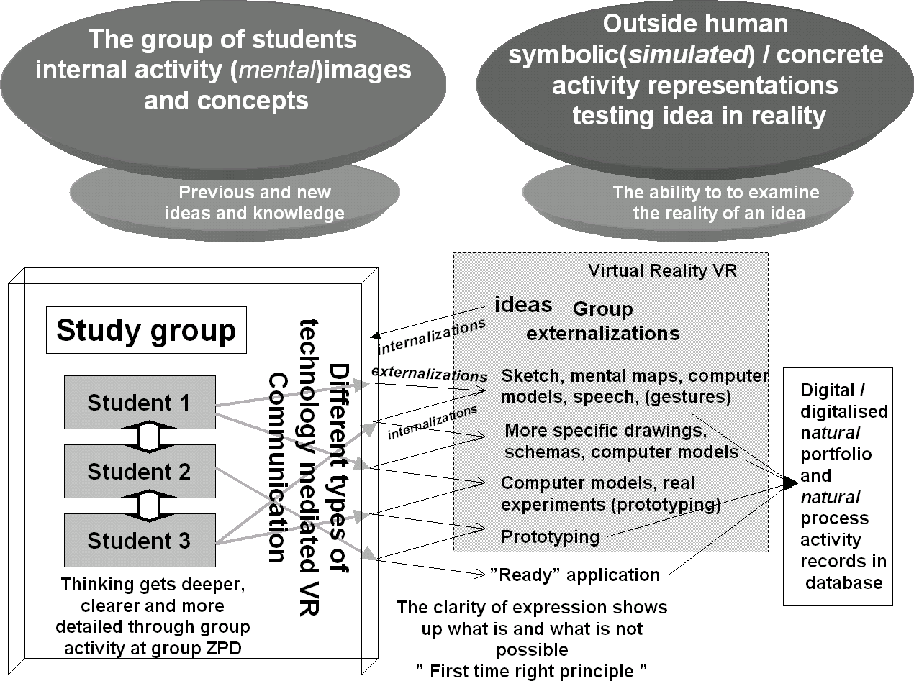
Figure 1. Important visual information (based on Lehtonen, Page, Thorsteinsson, & Ruokamo, 2005)
This sentence begins a new paragraph. This sentence simply provides something to place in this template document. And so does this. This sentence simply provides something to place in this template document. And so does this. This sentence simply provides something to place in this template document. And so does this. This sentence simply provides something to place in this template document. And so does this. This line ends the paragraph.

3.1 Subheading
This sentence begins a new paragraph. This sentence simply provides something to place in this template document. And so does this. This sentence simply provides something to place in this template document. And so does this. This sentence simply provides something to place in this template document. And so does this. This sentence simply provides something to place in this template document. And so does this. This line ends the paragraph.
This sentence begins a new paragraph. This sentence simply provides something to place in this template document. And so does this. This sentence simply provides something to place in this template document. And so does this. This sentence simply provides something to place in this template document. And so does this. This sentence simply provides something to place in this template document. And so does this. This line ends the paragraph.

3.2 Subheading
This sentence begins a new paragraph. This sentence simply provides something to place in this template document. And so does this. This sentence simply provides something to place in this template document. And so does this. This sentence simply provides something to place in this template document. And so does this. This sentence simply provides something to place in this template document. And so does this. This line ends the paragraph.

4 Methods
This sentence begins a new paragraph. This sentence simply provides something to place in this template document. And so does this. This sentence simply provides something to place in this template document. And so does this. This sentence simply provides something to place in this template document. And so does this. This sentence simply provides something to place in this template document. And so does this. This line ends the paragraph.
This sentence begins a new paragraph. This sentence simply provides something to place in this template document. And so does this. This sentence simply provides something to place in this template document. And so does this. This sentence simply provides something to place in this template document. And so does this. This sentence simply provides something to place in this template document. And so does this. This line ends the paragraph.

5 Results
This sentence begins a new paragraph. This sentence simply provides something to place in this template document. And so does this. This sentence simply provides something to place in this template document. And so does this. This sentence simply provides something to place in this template document. And so does this. This sentence simply provides something to place in this template document. And so does this. This line ends the paragraph. Table 1. lists our findings.
Table 1. Major findings
Information | r | g
1 | xy | xx
2 | xx | yx

This sentence begins a new paragraph. This sentence simply provides something to place in this template document. And so does this. This sentence simply provides something to place in this template document. And so does this. This sentence simply provides something to place in this template document. And so does this. This sentence simply provides something to place in this template document. And so does this. This line ends the paragraph.

5.1 Implications
This sentence begins a new paragraph. This sentence simply provides something to place in this template document. And so does this. This sentence simply provides something to place in this template document. And so does this. This sentence simply provides something to place in this template document. And so does this. This sentence simply provides something to place in this template document. And so does this. This line ends the paragraph.

5.2 Possible Applications
This sentence begins a new paragraph. This sentence simply provides something to place in this template document. And so does this. This sentence simply provides something to place in this template document. And so does this. This sentence simply provides something to place in this template document. And so does this. This sentence simply provides something to place in this template document. And so does this. This line ends the paragraph.
This sentence begins a new paragraph. This sentence simply provides something to place in this template document. And so does this. This sentence simply provides something to place in this template document. And so does this. This sentence simply provides something to place in this template document. And so does this. This sentence simply provides something to place in this template document. And so does this. This line ends the paragraph.

6 Conclusions
This sentence begins a new paragraph. This sentence simply provides something to place in this template document. And so does this. This sentence simply provides something to place in this template document. And so does this. This sentence simply provides something to place in this template document. And so does this. This sentence simply provides something to place in this template document. And so does this. This line ends the paragraph.
This sentence begins a new paragraph. This sentence simply provides something to place in this template document. And so does this. This sentence simply provides something to place in this template document. And so does this. This sentence simply provides something to place in this template document. And so does this. This sentence simply provides something to place in this template document. And so does this. This line ends the paragraph.
This sentence begins a new paragraph. This sentence simply provides something to place in this template document. And so does this. This sentence simply provides something to place in this template document. And so does this. This sentence simply provides something to place in this template document. And so does this. This sentence simply provides something to place in this template document. And so does this. This line ends the paragraph.

Acknowledgements
You may list all contributors who do not meet the criteria for authorship, such as a person who provided purely technical help, writing assistance, or a department chair who provided only general support. Financial and material support should also be acknowledged.

References
APA. (2001). Publication manual of the American Psychological Association 5th ed. Washington: American Psychological Association.
Disney. (2000). Disney.com - Where the magic lives online! Retrieved 25th August, 2000, from http://www.disney.com/
Corkum, V., & Moore, C. (1998). The Origins of Joint Visual Attention in Infants. Developmental Psychology, 34(1).
Kaptelinin, V., & Nardi, B. A. (1997). Activity theory: Basic concepts and applications. Retrieved 1st May, 2000, from http://www.acm.org/sigchi/chi97/proceedings/tutorial/bn.htm
LeDoux, J. E. (1986). The neurobiology of emotion. [Chap. 15]. In J. E. LeDoux & W. Hirst (Eds.), Mind and Brain: diologues in cognitive neuroscience. New York: Cambridge.
Lehtonen, M. (2005). Simulations as mental tools for network-based group learning. In P. Nicholson, B. J. Thompson, M. Ruohonen, & J. Multisilta (Eds.), E-Training Practices for Professional Organisations. IFIP TC3 / WG3.3 Fifth working conference on eTrain practices for professional organizations (eTrain 2003) Open Working Conference, 7–11th July, 2003 in Pori, Finland. London: Kluwer Academic Publishers, 11–18.
Lehtonen, M., Hyvönen, P., & Ruokamo, H. (2005). Learnt without joy, forgotten without sorrow! The significance of emotional experience in the processes of online teaching, studying and learning. In H. Ruokamo, P. Hyvönen, M. Lehtonen, & S. Tella (Eds.), Proceedings of the 12th International NBE 2005 Conference: Teaching-Studying-Learning (TSL) Processes and Mobile Technologies: Multi-, Inter- and Transdisciplinary (MIT) Research Approaches (pp. 153–163). Rovaniemi: Lapin yliopistopaino.
Lehtonen, M., Thorsteinsson, G., Page, T. & Ruokamo, H. (2005). A Virtual Learning Environment for the Support of Learning in Technology Education. Advanced Technology for Learning (ATL), 2(3), 129–139.
Lehtonen, M., Page, T., & Thorsteinsson, G. (2005). Emotionality considerations in virtual reality and simulation based learning. In Kinshuk, D. G. Sampson, P. Isafas, L. Rodrigues, & P. Barbosa (Eds.), Proceedings of the IADIS international conference on Cognition and Exploratory Learning in Digital Age (CELDA 2005) 14 - 16 December 2005, Porto, Portugal [Endorsed by: IEEE Technical Committee on Learning Technology and Japanese Society of Information and Systems in Education] (pp. 26–36): IADIS International association for development of the information society (IADIS Press).
Lehtonen, M., Page, T., Thorsteinsson, G., & Ruokamo, H. (2005). A Virtual Learning Environment for the Support of Teaching, Studying and Learning in Technology Education. [Best paper award]. In V. Uskov (Ed.), Proceedings of fourth IASTED International Conference on Web-Based Education – WBE 2005 held February 21–23, 2005, Grindelwald, Switzerland (pp. 109–118). Anaheim, CA, USA: ACTA Press.
Page, T., Lehtonen, M., & Thorsteinsson, G. (2006). The web-orientation agent (WOA) for simulated learning in technology education. International Journal of Learning Technology (IJLT), 2(1), 62–76.
Page, T., Lehtonen, M., Thorsteinsson, G., & Arunachalam, S. (in press). Emotional and aesthetic factors of virtual mobile learning environments. International Journal of Mobile Learning and Organisation (IJMLO).
Vahtivuori-Hänninen, S., Lehtonen, M., & Torkkeli, M. (2005). Group Investigation, Social Simulations, and Games as Support for Network-Based Education. In H. Ruokamo, P. Hyvönen, M. Lehtonen & S. Tella (Eds.), Proceedings of the 12th International NBE 2005 Conference: Teaching-Studying-Learning (TSL) Processes and Mobile Technologies: Multi-, Inter- and Transdisciplinary (MIT) Research Approaches (pp. 123-131). Rovaniemi, Finland: Lapin yliopistopaino.

